# Apply Styling on Header & Footer:

* To style the header and footer, use the AEM Style System and update CSS styles in the ui.frontend module.

**Header:**

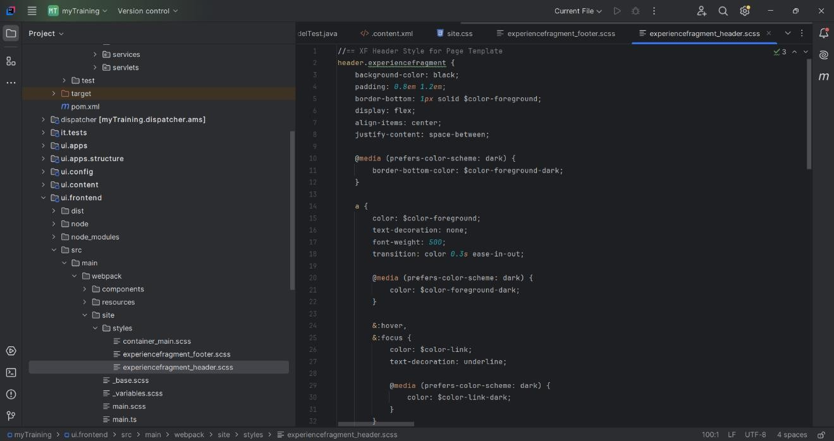

**Footer:**

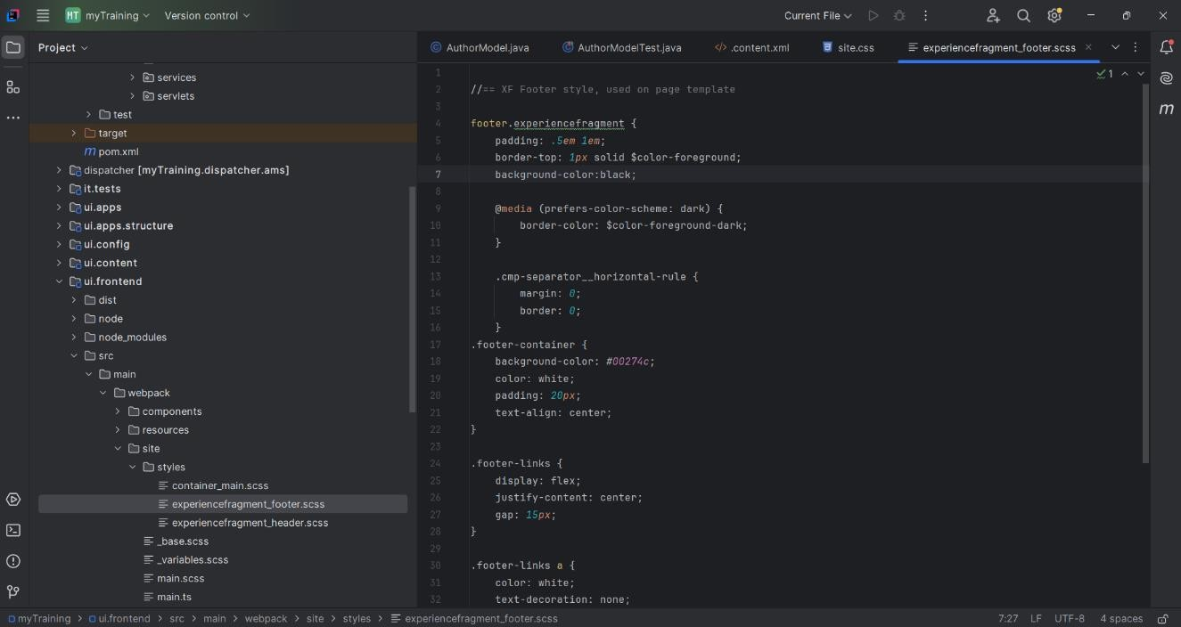

**Custom Page Property**

* A new text area property 'addScript' was added to the Book Page component, allowing authors to inject scripts dynamically.

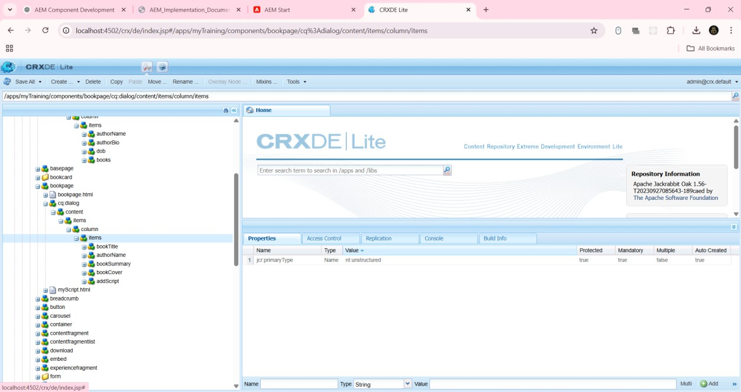

# Updates to Author Component :

A new text property and a multifield for books were added to the Author component. A Sling model was implemented to fetch these properties.

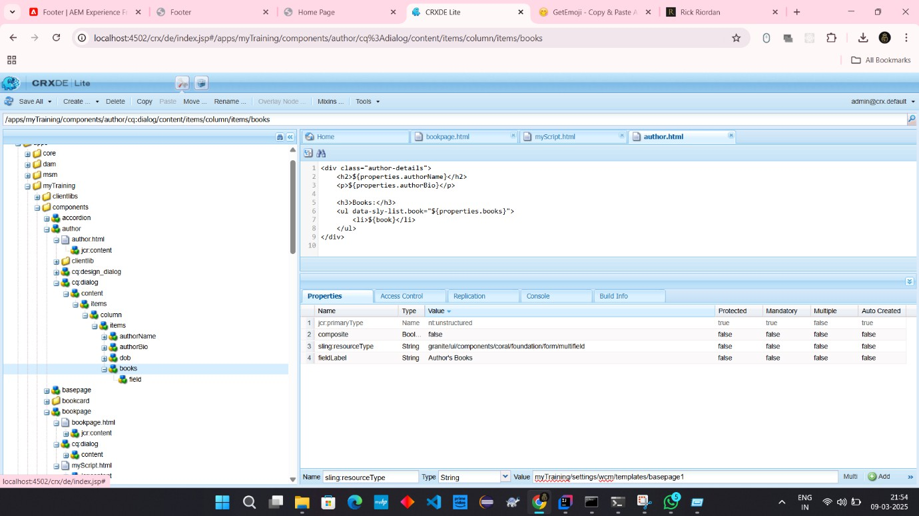

**Author Details Component implemented by multifield:**

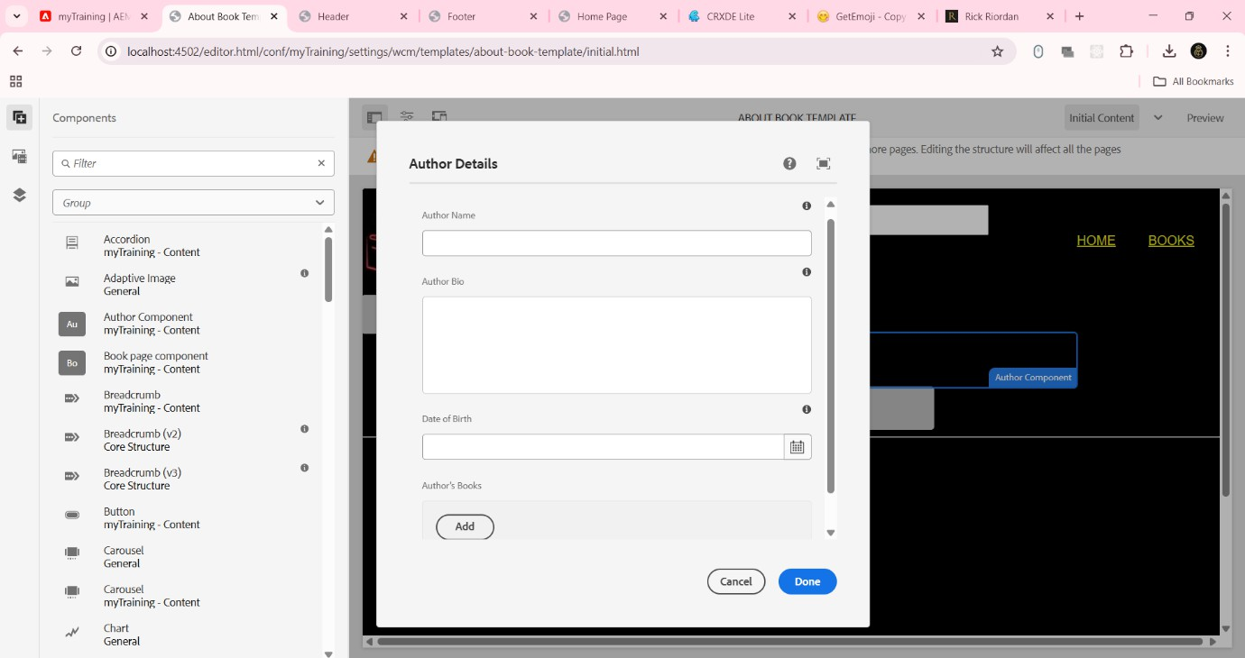

# Creating 'About Book Template' :

* A new template was created using the base page template, enabling authors to generate book-related pages efficiently.

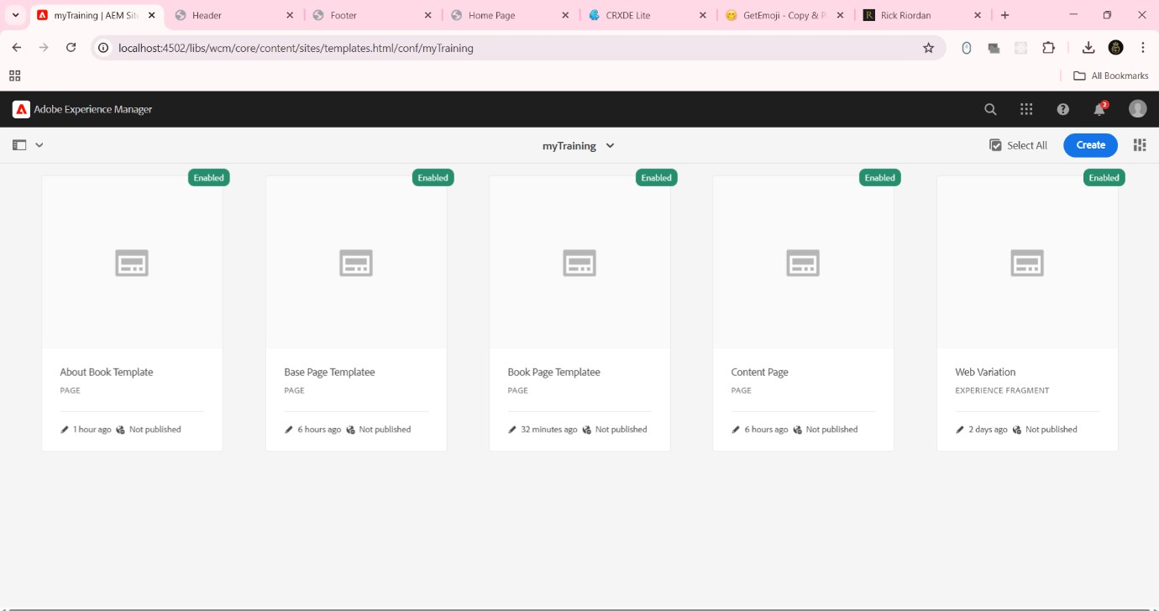

**Book component template:**

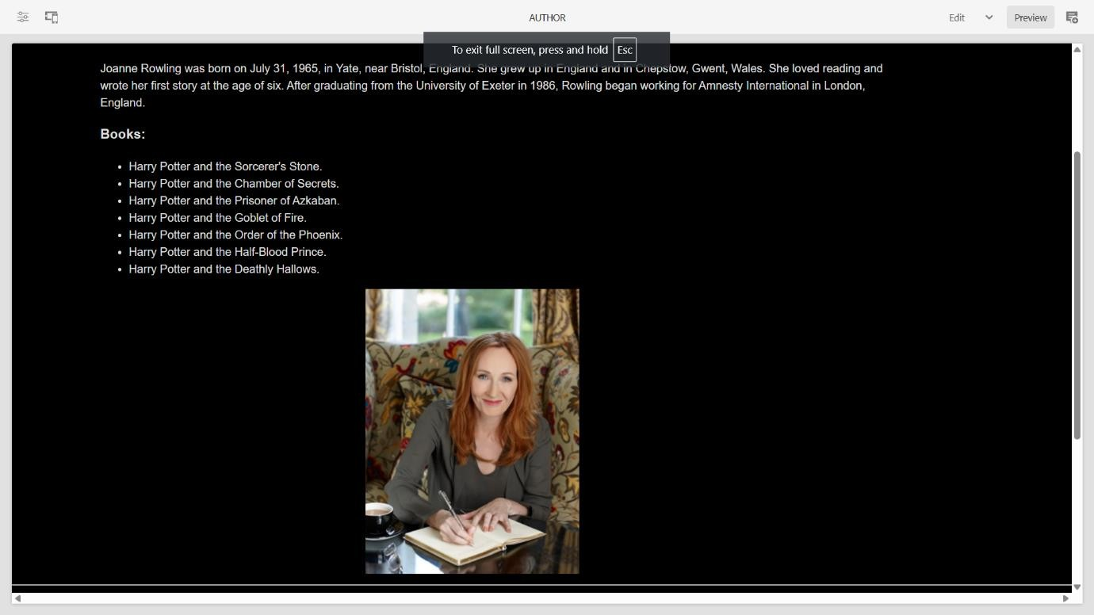

# Creating Book Page Component:

* A Book Page component was developed, utilizing the base page template. It fetches properties and allows dynamic content addition.
* 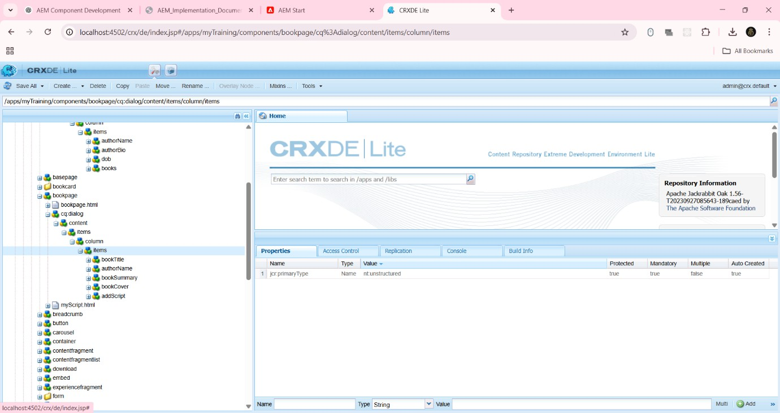Configure AuthorModel for accepting multifield inputs from user

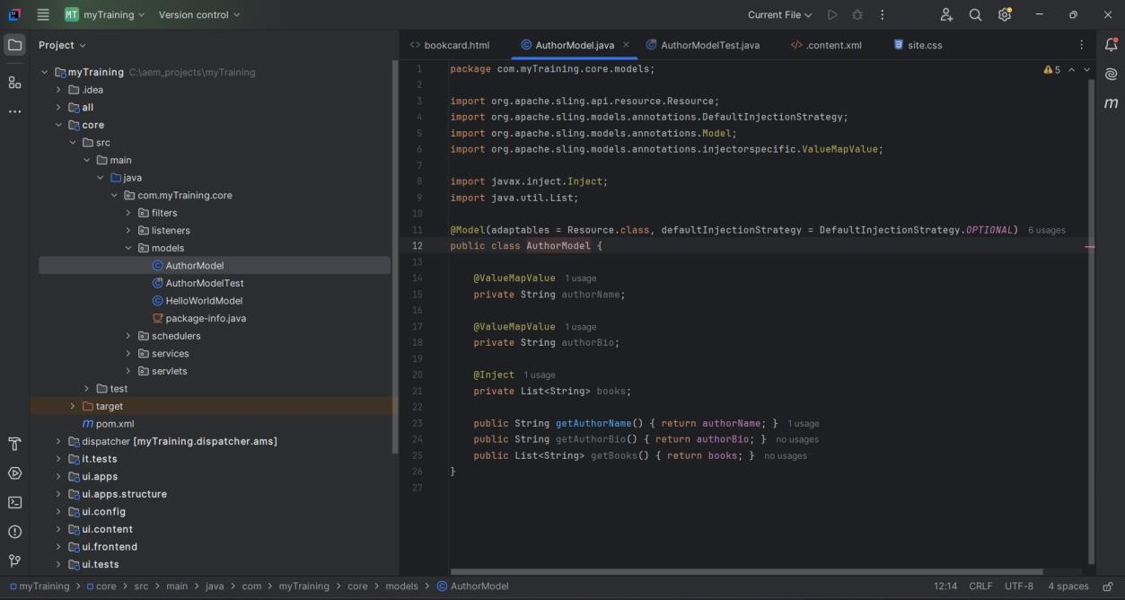

**Home page:**

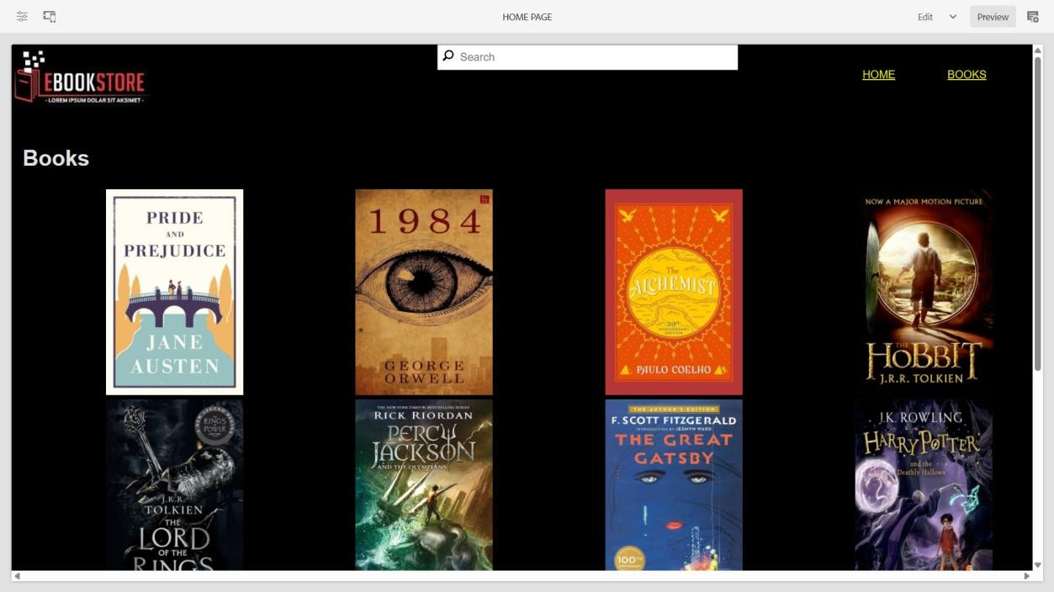

**Books page:**

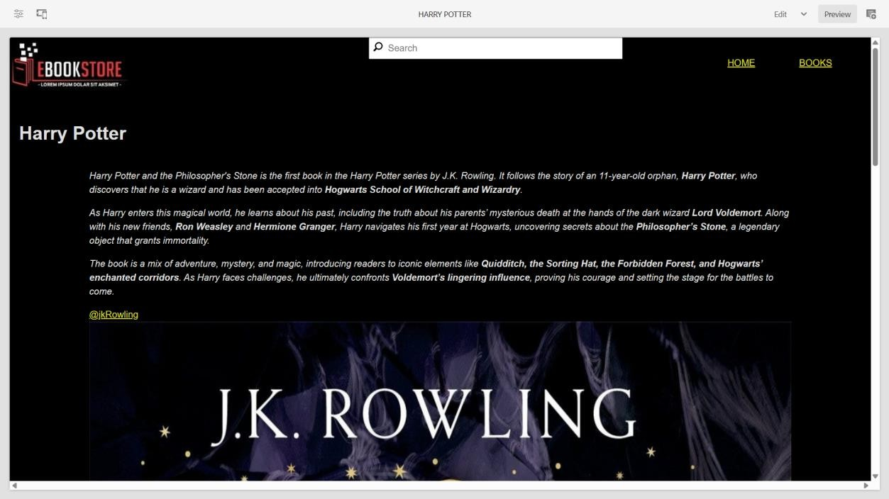

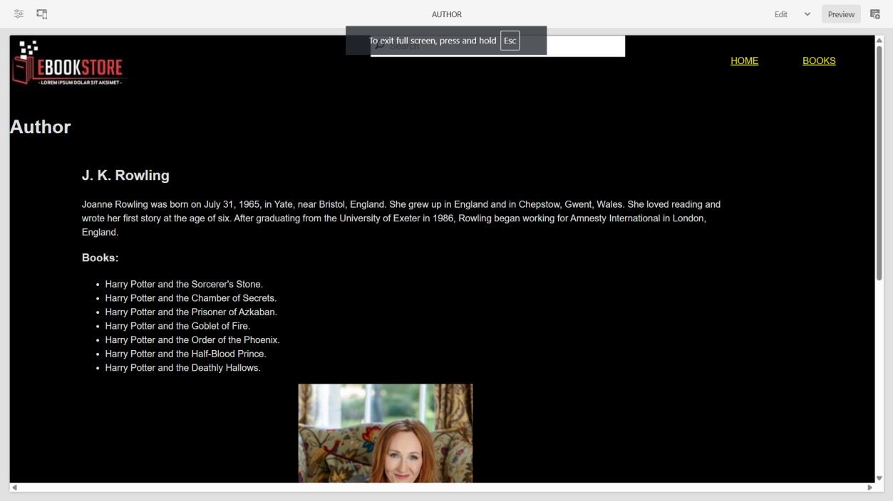**Author page:**